Q1.
Answer is B.

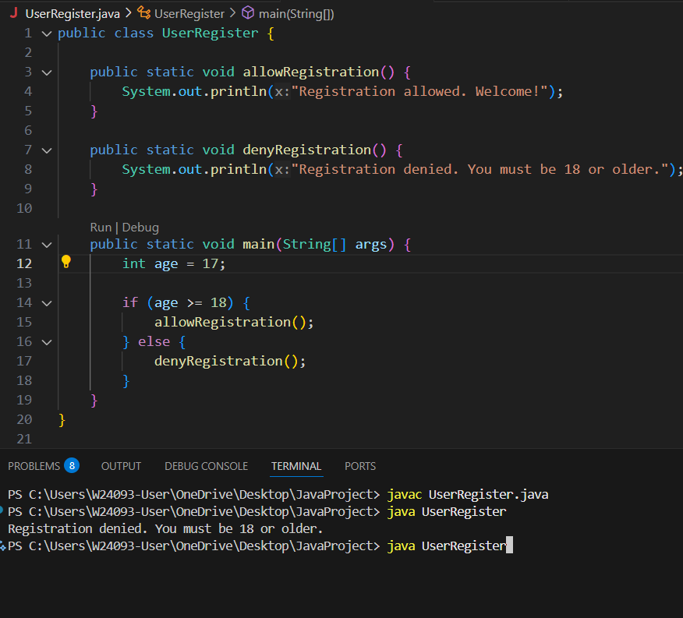

A: A while loop repeats as long as the condition is true.

B: A simple one-time condition check.

C: Swith is for specific value.

D: do-while loop repeat code until ther user age become 18.

Q2.
Answer is A.

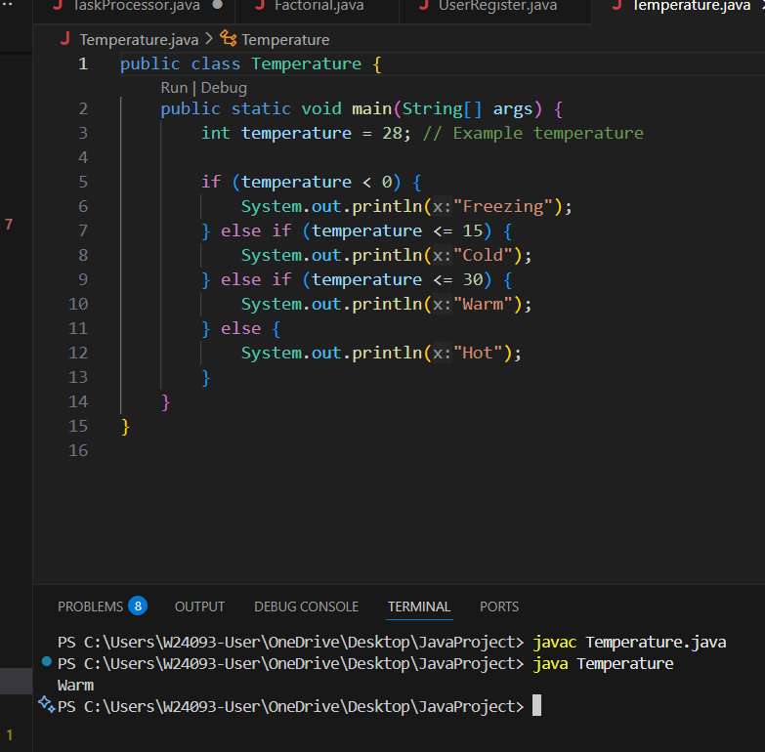

A: if-else if-else chain is perfect for multiple checking.

B: Switch is work with discrete values.

C: While loop used for repeat.

D: Same as While. At First ,not checking do one time and repeat loop.

Q3.
Answer is D.

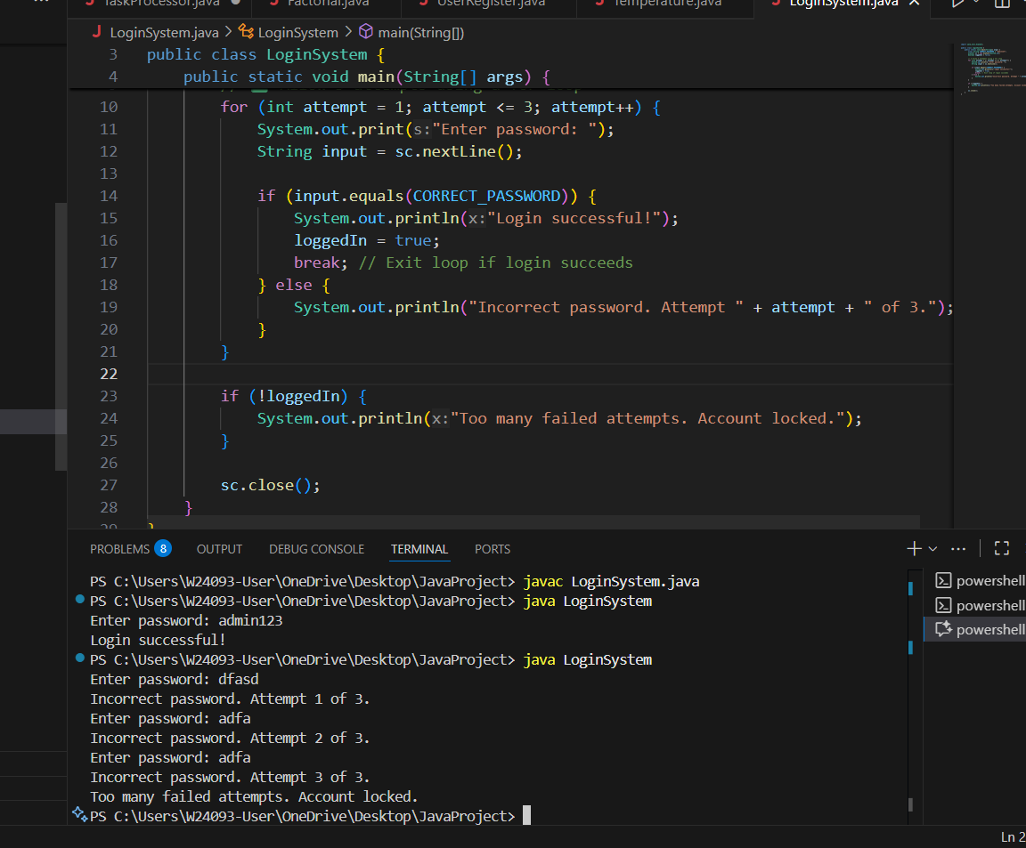

A: Only checks once, doesn’t handle repeated attempts

B: Used for specific fixed values, not for counting attempts or looping.

C: Can work, but less clear

D: Clear and simple to implement.Caused of fixed number of iterations.

Q4.
Answer is A.

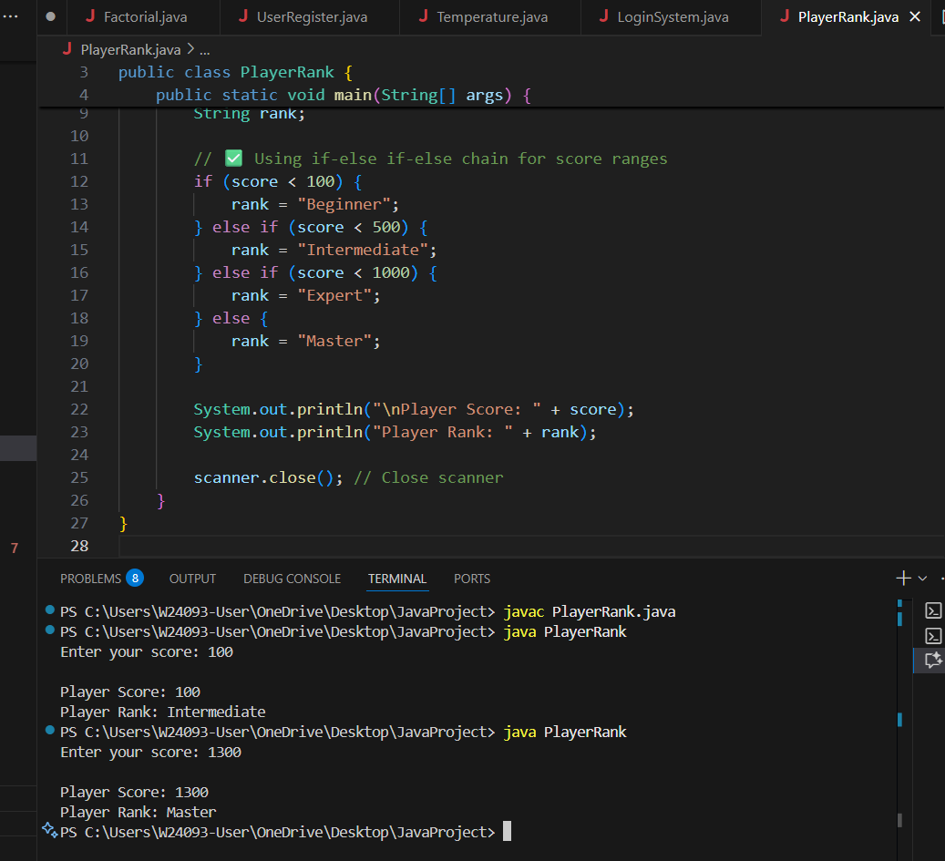

A: if-else if-else chain is used for checking multiple score ranges.

B: Works only with specific values, not ranges.

C: Used for repeated execution while a condition is true.

D: Used for counting or repeating code.

Q5.
Answer is A.

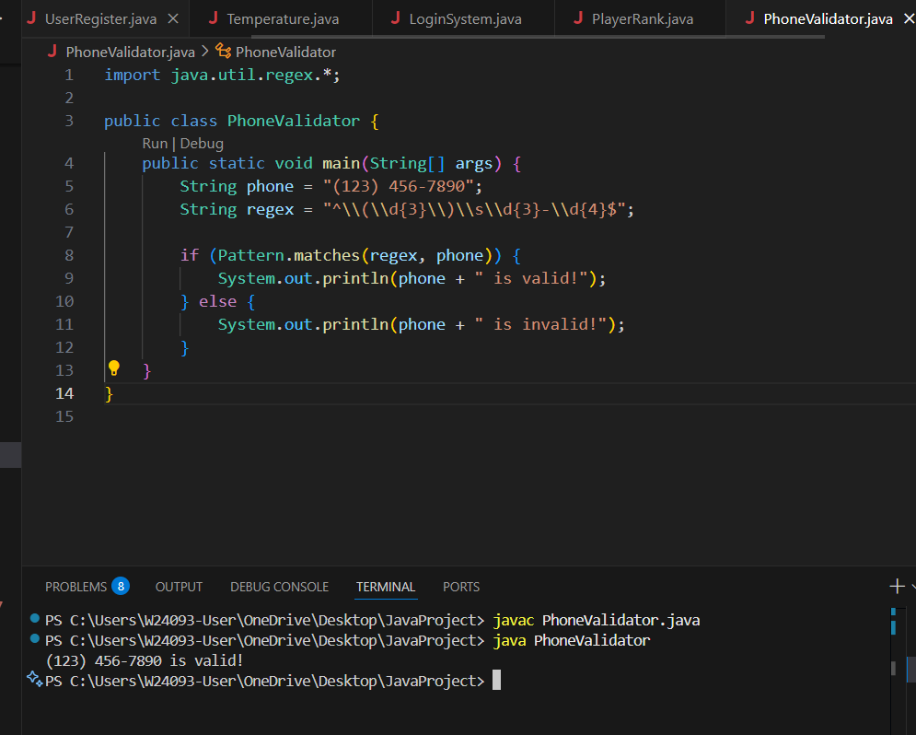

A: Correctly escapes parentheses, uses \s for space.

B: Works but \s is more general.

C: No, doesn’t match (123) 456-7890.

D: No, format is different.

Q6.
Answer is B.

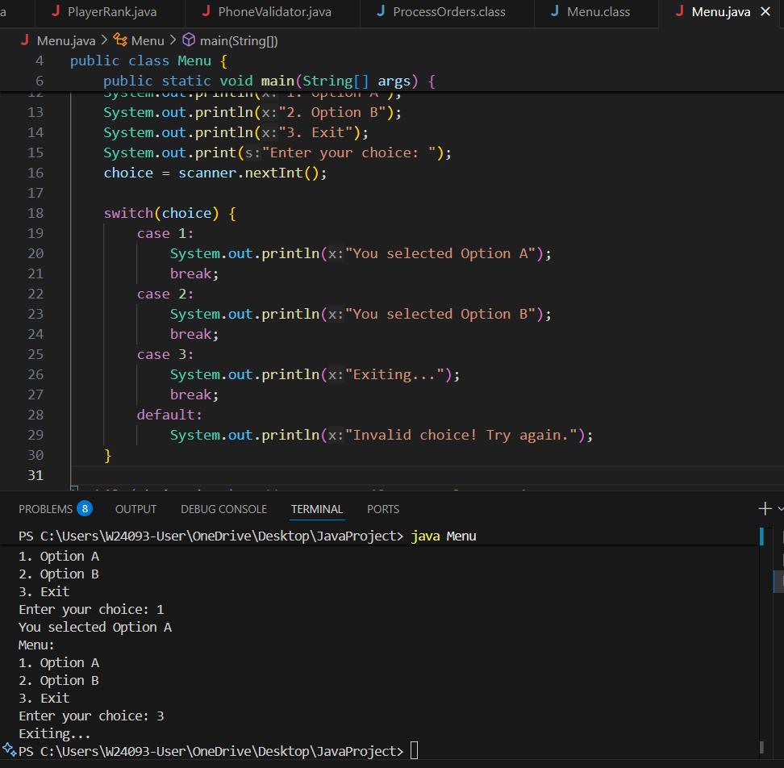

A: Can Work, but become long and less readable.

B: Best for fixed numeric or string choices in menus. Clean, clear, and efficient.

C: Used to repeat actions until a condition is met. Not for handling a single choice.

D: Useful for repeating the menu until the user exits, but not for handling a single choice itself.

Q7.
Answer is A.

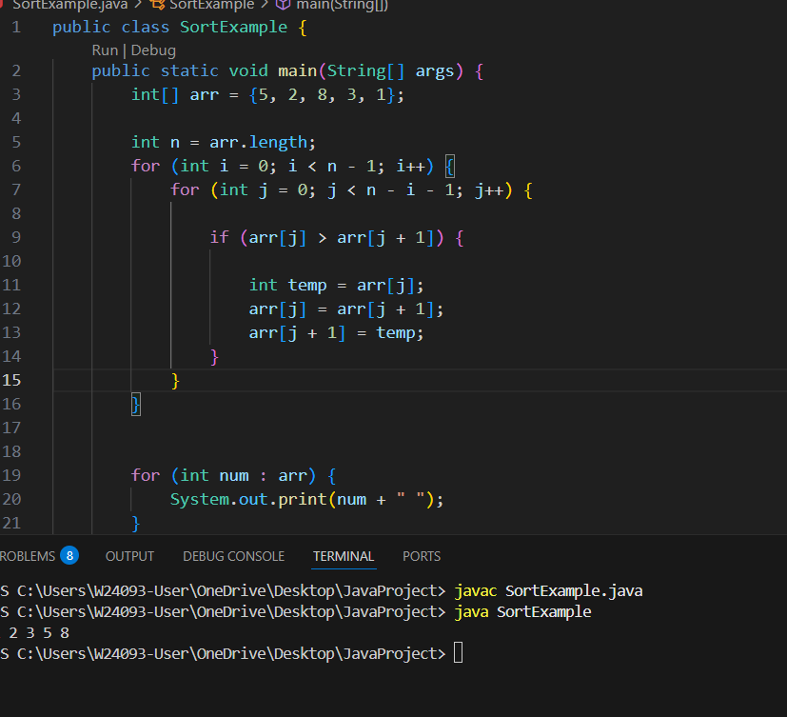

A: Perfect for comparing two elements and deciding to swap.

B: Not suitable for numeric comparison ranges.

C: Used to repeat operations, not for a single comparison.

D: Used to iterate through the array, not for conditional comparison itself.

Q8.
Answer is B.

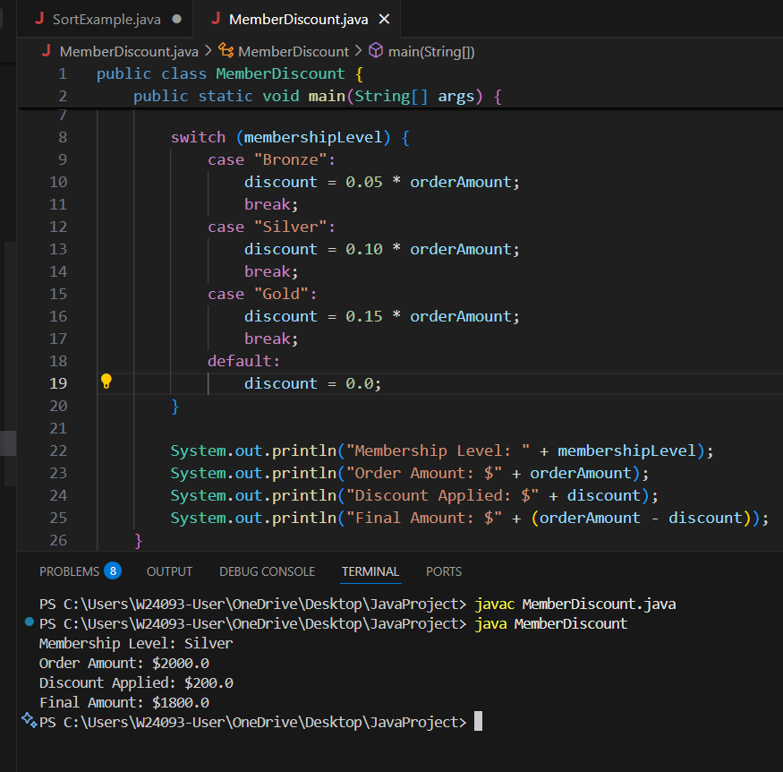

A: if-else if-else is possible but less readable.

B: Switch is best for fixed value . Correct one.

C: while-Loops are used for repeated execution, not for checking fixed value.

D: Same as while — not for one-time decision-making.

